Appendix A
Download and Install MATLAB 2023a Software

Try to download and install the updated version of MATLAB software at any time.
Perform the following steps to download and install the MATLAB R2023a 30-day free trial version as well as related Toolboxes:

- After submitting your request for free 30-day trial version of MATLAB, go to the site https://www.mathworks.com/downloads/web_downloads/11526200 to open the free downloading wizard, as shown in Figure A.1.

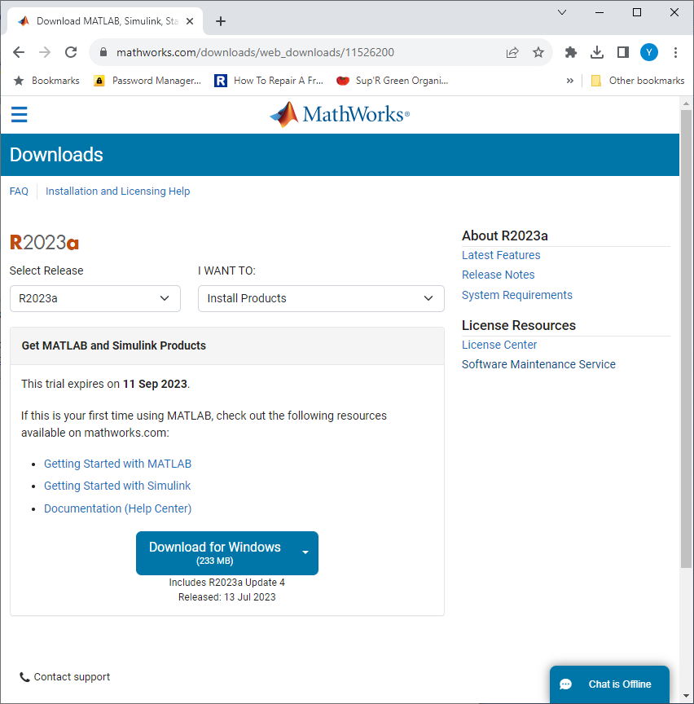

Figure A.1 The opened downloading wizard.

- Click on the Download for Windows button shown in Figure A.1 to starting the download process.
- As the download process id done, open the File Explorer and go to the Downloads folder on your machine. Then double click on the downloaded file, matlab_R2023a_win64.exe, to begin the installing process.
- Complete the login process with your username and password that were used when you sent request to MathWorks, and click on the Next button to go to the PRODUCTS wizard, as shown in Figure A.2.

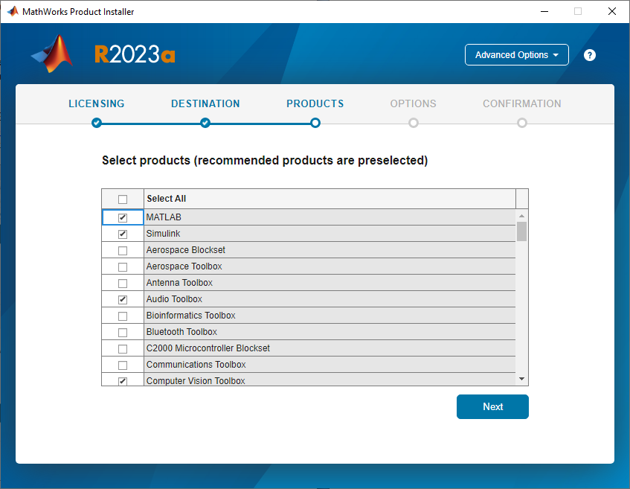

Figure A.2 The opened PRODUCTS wizard.

- On this wizard, we can to select all related Toolboxes we like to use in our projects. Select the following components and Toolboxes by clicking on each of them:

  - Simulink
  - Audio Toolbox
  - Computer Vision Toolbox
  - Control System Toolbox
  - Data Acquisition Toolbox
  - Deep Learning Toolbox
  - DSP System Toolbox
  - Fuzzy Logic Toolbox
  - Image Processing Toolbox
  - Signal Processing Toolbox
  - Simulink Control Design
  - Statistics and Machine Learning Toolbox
  - System Identification Toolbox

- Then click on the Next button to continue.
- In the next wizard, the OPTIONS wizard, check the Add shortcut to desktop checkbox to add a shortcut of this MATLAB to the desktop to make it easy to be used. Then click on the Next button to continue.
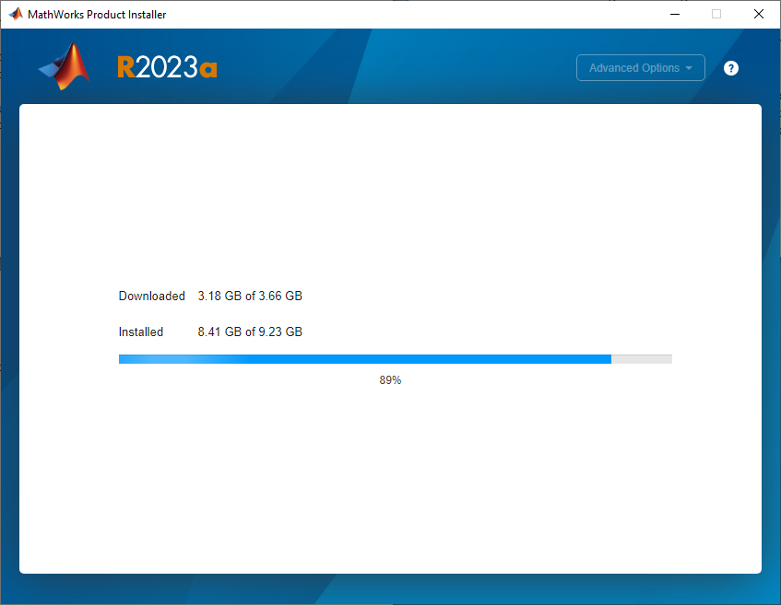

Figure A.3 The installation starts.

- Click on the Begin Install button to start this installation process. The installation process is beginning, as shown in Figure A.3.
- When the installation process is done, which is shown in Figure A.4, click on the Close button to complete this process.

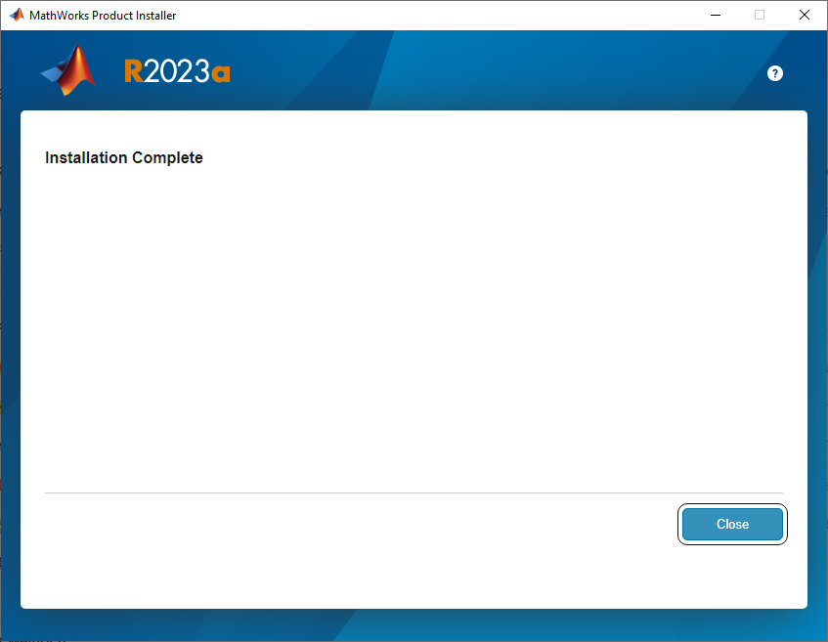

Figure A.4 The installation ends.

